Statement reconciliation process
Step 1: Once we receive the statement from the vendor, we must go through P21, open the AP Drill Down by Vendor screen, and set the vendor name and date range.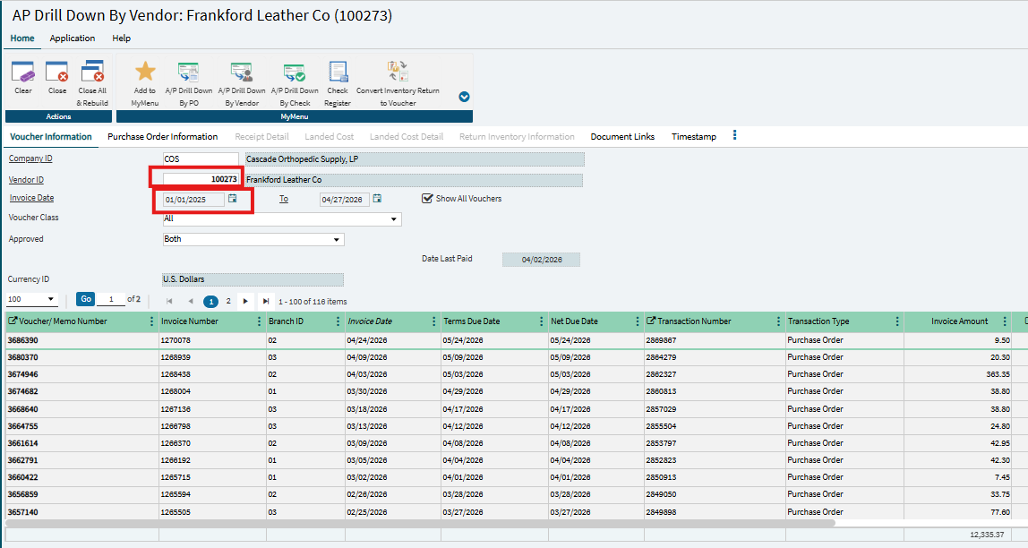
Step 2: Download the data from the AP Drill Down by Vendor screen. Right click on any line, then go to Services and select Save As.
Once the Select Columns to Save screen appears (see image below), choose the information needed to begin the statement reconciliation.
The most important fields are: Amount Paid, Invoice Amount, Invoice Date, Invoice Number, and Transaction Number (PO Number).
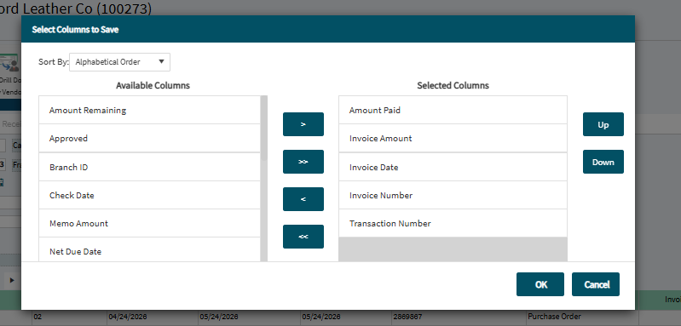
Step 3: Once we have both files, we can begin the reconciliation process. The fastest way to do this is by using a simple VLOOKUP formula in Excel to match the Invoice Number. Do not use the Transaction Number (PO Number) because it may not return the correct invoice, since manually processed invoices may not have a PO Number.

File from P21 with data
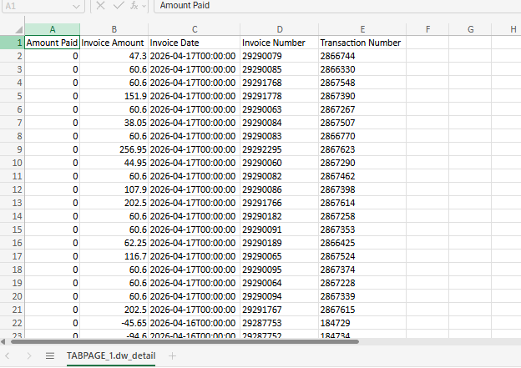
File with the statement sent by the vendor
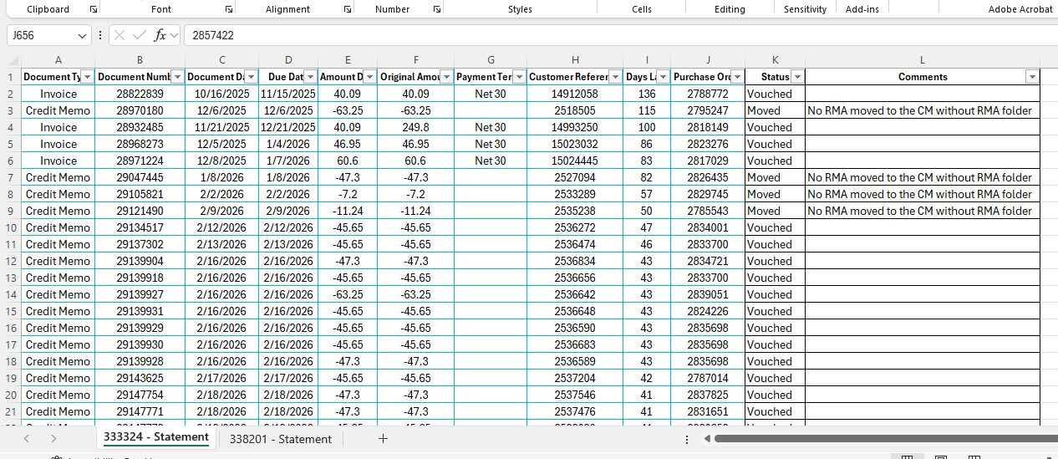

File already reconciled
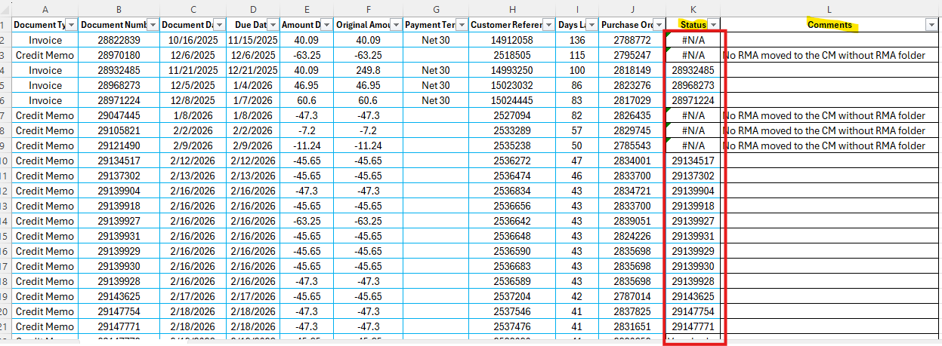
In this file, we need to create two new columns: Status and Comments.
In the Status column, enter the status of the invoice or credit. In the Comments column, add a brief note about the invoice or credit.
Scenarios that we can find while we are working on the reconciliation.
Scenario 1: The first time we reconcile the statement, the status may appear as the invoice or credit number. For example, if you see 2457840, it means the invoice has already been vouched, and you can update the Status column from N/A to Vouched.
Scenario 2: If the Status column shows N/A, we must investigate why the invoice or credit has not been vouched yet.
Reason 1: We haven’t received the invoice or credit copy.
In this scenario, first review the AP inbox to confirm that the invoice or credit was not received. Once confirmed, check the SPS portal (for EDI vendors) or the vendor’s invoice portal, if available.
If the vendor does not belong to our EDI vendors or does not have an invoice portal, we must send an email requesting copies of the missing invoices.
Reason 2: We have received the invoice.
In this scenario, we need to determine why the invoice was not vouched. There are two possible reasons:
- The item(s) were canceled.
- The item(s) have not yet been received.
Each scenario requires a different approach, but first, we have to confirm whether the invoice is for a warehouse or a drop shipment.
If it is a warehouse invoice, we must go to P21 and open the PO Drill Down by PO screen. Check the PO notes. If there are no notes and the PO has not been fully received, we need to review the PDF invoice for a tracking number.
- If the tracking number is not listed in the invoice copy, we must email the ETA team to request it.
- Once we have the tracking number, we need to contact the warehouse team to follow up on the missing items.
If some items are marked as received but not the ones in question, and there are notes on the PO, email the warehouse team and always CC Shayla Isaacs.
For items with errors or cancellations, we need to send an email to Shayla Isaacs requesting assistance.
If it is a drop shipment invoice, we need to check the PDF invoice for the tracking number. If the tracking number is not included, we must send an email to the ETA team requesting it.
Once we have the tracking number, we need to verify whether the items have been delivered by checking the carrier’s website (e.g., UPS, FedEx).
After confirming that the items were delivered, we need to send an email to the DS Billing team requesting assistance in marking the items as received.
Reason 3: Duplicate invoices.
If it is a drop shipment invoice, we just need to move it to the Drop Shipments Issues folder.
If it is a warehouse invoice, we must confirm with the warehouse team whether the extra items were received. We can check the PO notes or send an email to the warehouse team. Once confirmation is received, we need to send an email to Shayla Isaacs to coordinate a new credit memo or to add the items to the PO.

